1. ATM Withdrawal – Custom Exception

Problem
Withdraw money only if:
· Amount > 0
· Amount ≤ balance
Else throw custom exception.

Solution
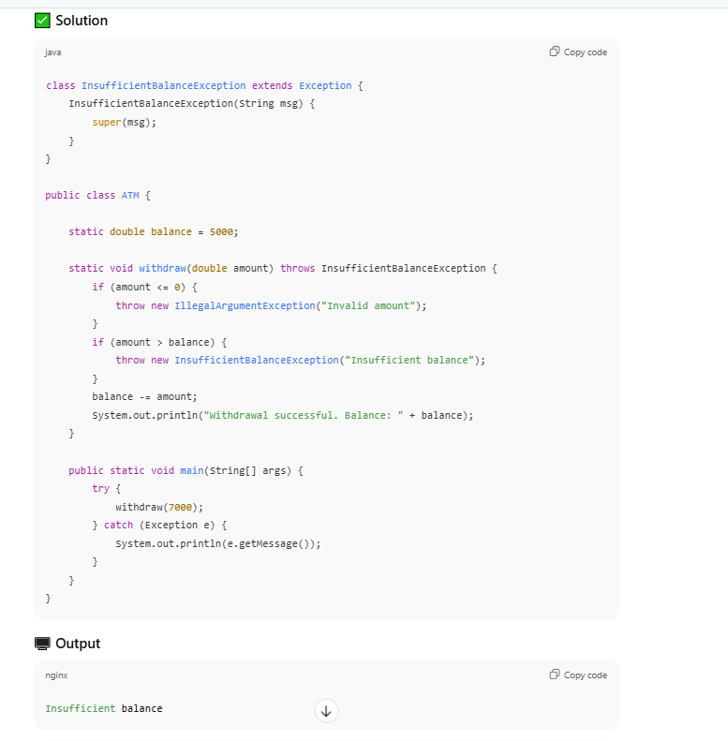

class InsufficientBalanceException extends Exception {
InsufficientBalanceException(String msg) {
super(msg);
}
}

public class ATM {

static double balance = 5000;

static void withdraw(double amount) throws InsufficientBalanceException {
if (amount <= 0) {
throw new IllegalArgumentException("Invalid amount");
}
if (amount > balance) {
throw new InsufficientBalanceException("Insufficient balance");
}
balance -= amount;
System.out.println("Withdrawal successful. Balance: " + balance);
}

public static void main(String[] args) {
try {
withdraw(7000);
} catch (Exception e) {
System.out.println(e.getMessage());
}
}
}

2. Login Validation System

❓ Problem
Validate username and password:
· Username not empty
· Password length ≥ 6
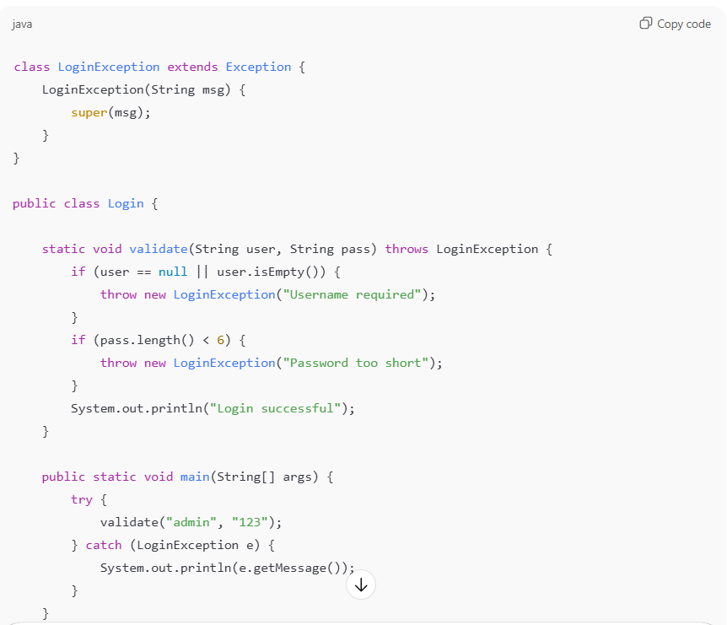

3.Nested try–catch

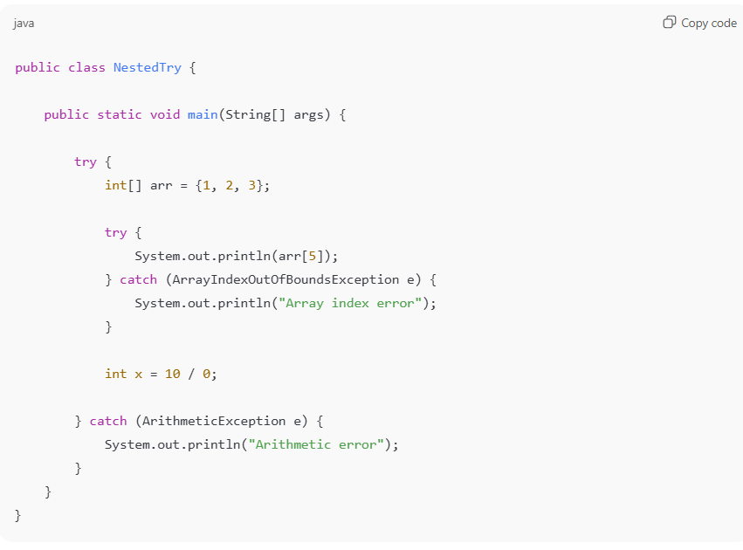
4.Fail student if marks < 35.
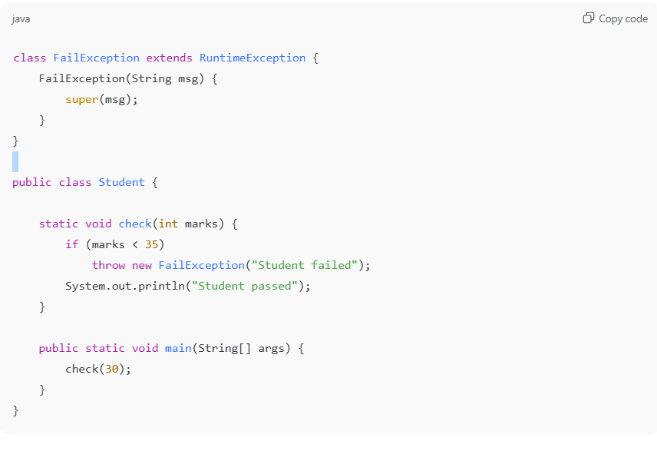
5. Input Validation Using Exception

Problem
Validate age and salary.
